Online SET Screen Guide

This view of your screen from different stages during the semester will allow you to see all activities related to your evaluations on a single comprehensive page. Relevant details and options are showcased for each evaluation when you need them, such as calls to action if tasks are incomplete and viewing response rates for live evaluations.

From the following page, you will be able to:

* **View response rates** - View real-time response rates to your live evaluation(s).
* **View or manage evaluation settings** - View (faculty) or adjust settings (SET coordinators) to your evaluation(s).

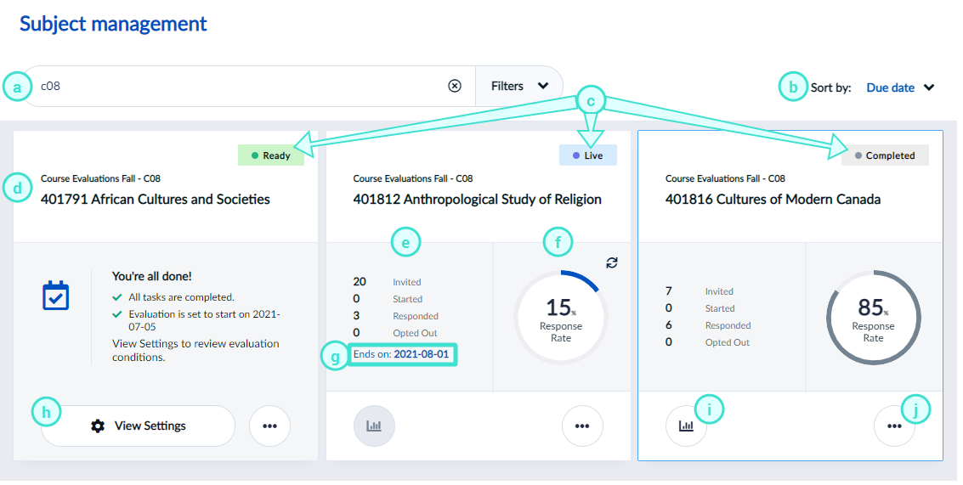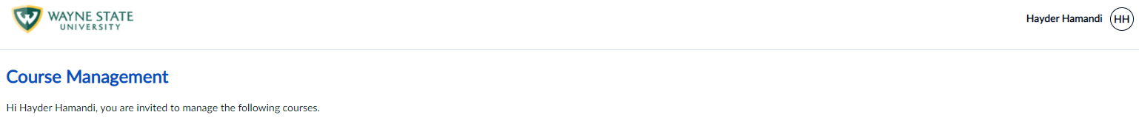JJ

LOG OFF

JD

John Doe

Hi John Doe, you are invited to manage the following courses.

**COURSE MANAGEMENT VIEW FEATURES**

|  |  |  |
| --- | --- | --- |
| 1. **Search bar** – This allows you to do a keyword search to locate specific evaluations. 2. **Sort by** – This allows you to sort your list by the due date or course name. 3. **Status** - Indicates the evaluation status. 4. **Evaluation** - Displays the evaluation semester, course, and instructor name. | 1. **Participant details** - Indicates the number of students who were invited, started, responded to, and opted out of the evaluation. 2. **Response rate** - Displays the number of responses the evaluation has received. 3. **End date** - Displays the deadline for students to complete their evaluation. 4. **View & Manage Settings**  * View – allows **faculty** to see students invited, responded, opted out, and the evaluation end-date. * Manage – allows **SET coordinators** to manage course details and the evaluation period. | 1. **Reports** – These are not available until after the evaluation period has closed for the entire University. 2. **More Options** – See   registered students under View Respondents or see (h) for Manage Settings. |

**FACULTY REMINDER EMAIL**

Faculty reminder emails to students who have not completed or submitted their evaluations are not available in Blue Online SET. The 'reminder email' feature for faculty **will be reinstated sometime soon**. Faculty may utilize Canvas to send reminder notifications to their students to complete their evaluations in the meantime.

