Go to the Language Testing International web page; <https://www.languagetesting.com/>

On the home page, ignore the menu at the top, go to where it says, Select a language

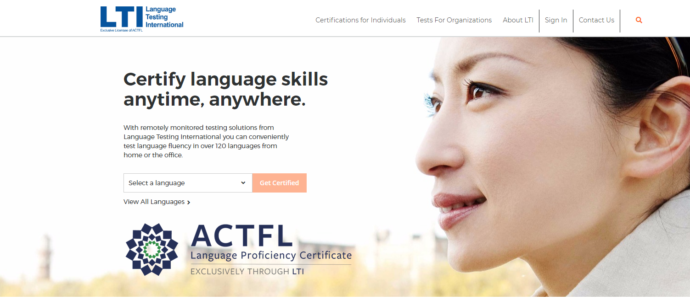

In the Select a language box, type and then select the language you want and click Get Certified

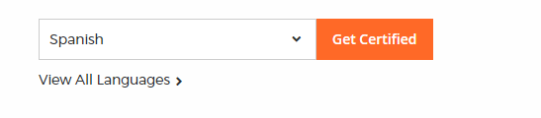

On the next page go to the side that says Student/Teacher, and second from the bottom find, Language Certification for Programs with ACTFL requirements

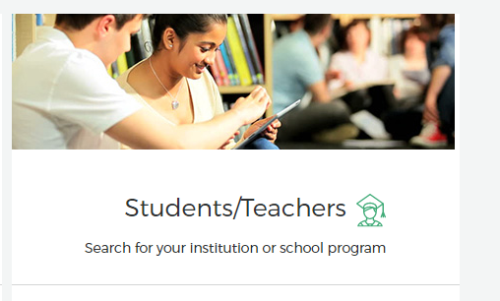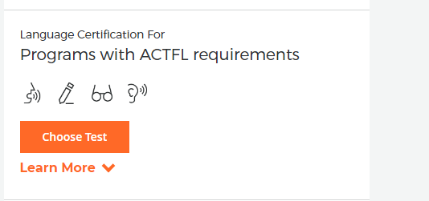

Select Choose Test

On the next page you select institution, Type Wayne in the box and then select Wayne State University

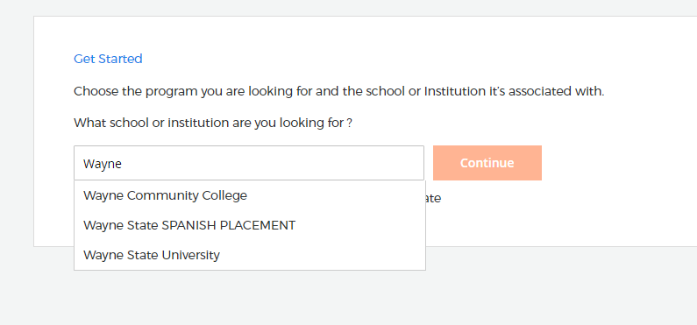

Do not select Wayne State SPANISH PLACEMENT, even if you are taking the Spanish language, unless you have been specifically directed to do so by the department of Classical & Modern Languages and Literatures. Be careful that you do not select Wayne Community College

Click Continue

On the next page what ever tests are available in that language will be displayed. There may be several there may be only one.

For the Oral Proficiency Interview, select ACTFL OPI or ACTFL OPIc if available. Do not select any other tests unless your program has specified that you need them.

After selecting the tests click Continue to Schedule

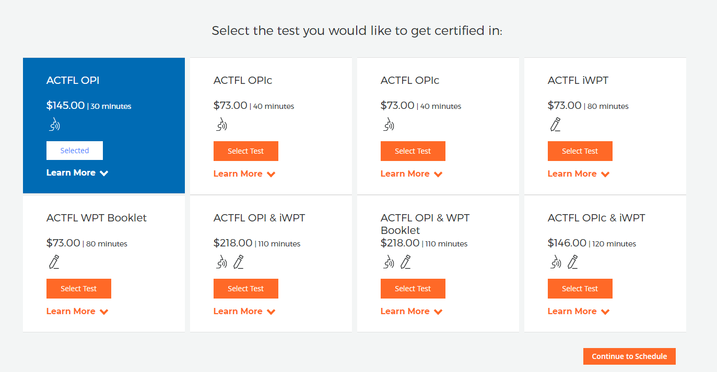

On the next page you schedule your test. There are two proctoring location options; Web-Based Proctoring – Examiity and Wayne State TE & RS. Wayne State proctoring is not currently available, we will resume when the university restrictions are lifted and we return to in-person proctoring. Select Web-Based. Note there is an additional $20 fee for web proctoring. Select your time zone, and first and second available dates and times. You may wish to add services to your order; then click Next.

At this point you will create an account or access a previously created account. You will then check out by entering your payment information and then confirm your order.