|  |
| --- |
| Student Evaluation of Teaching |
| Your guide to accessing faculty longitude results online |
| For more information please contact set@wayne.edu or (313)577-3400 |
|  |



*We recommend using the following browsers:*

* ***Internet Explorer*** http://png-2.findicons.com/files/icons/1008/quiet/128/internet_explorer.png
* *Mozilla Firefox (35.0.1)*
* *Safari (v8.0.6) for MAC users*

1. Log into **Academica:**

***Accessing from home (on-campus users please disregard***

*To access COGNOS from home, please visit* [https://computing.wayne.edu/vpn/](https://computing.wayne.edu/vpn/f)*.* ***Please contact the C&IT Help Desk at 313.577.4778 for assistance as needed.***

1. Look to the left of the screen for menu selections under ***WSU Resources*** .
2. Click on the second option **Faculty Instructional Resources**.
3. Under **Faculty Instructional Resources** -- scroll down and click on ***Student Evaluation of Teaching Reports*** (which is the third option from the bottom.

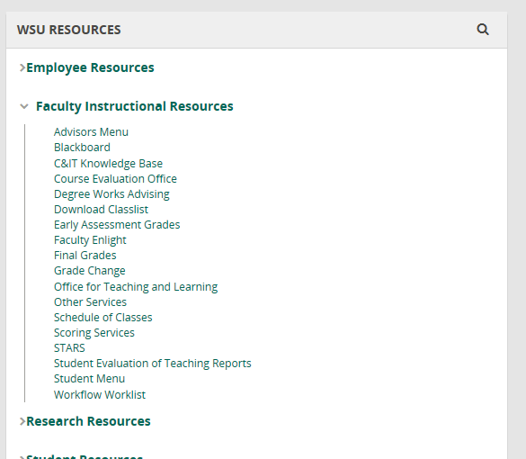

Look to the left of the screen under **“*WSU RESOURCES”*** click on ***“Faculty Instructional Resources”*** next click on “***Student Evaluation of Teaching Reports***”

The following ***Testing, Evaluation and Research Services*** screen will appear.

1. Click on the ***Deans, Chairs and Faculty*** link below (located on the left side of the screen).

*Note: If a blank screen appears you do not have access, please email set@wayne.edu.*

Top of Form

|  |  |  |
| --- | --- | --- |
|  |  |  |

Click on “Deans, Chairs and Faculty” link for a

Longitudinal Report.

The following ***Longitudinal Report*** screen will appear.

1. Click on the ***Academic Period Start:*** drop down box and select the (oldest term) for your starting Academic period.
2. Next click on the ***Academic Period End:*** drop down box and select the (current term) for your ending Academic Period.

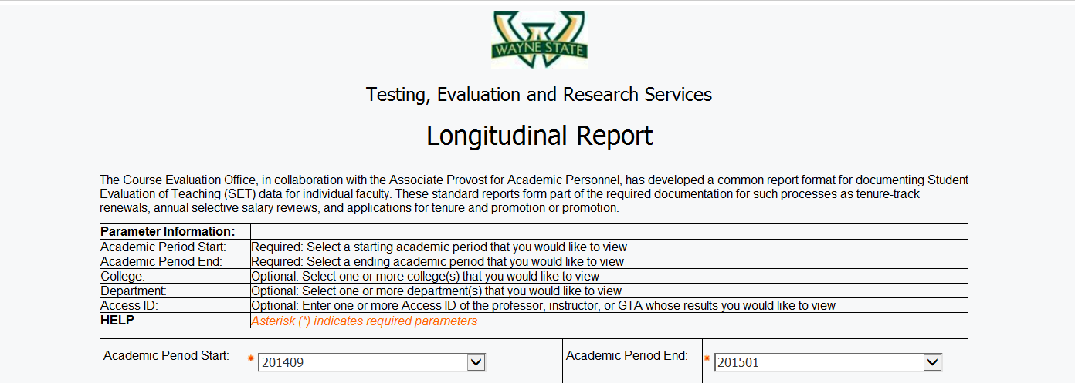

Select the **Academic Period End:** (current term) from the drop down box

Select the **Academic Period Start:** (oldest term) from the drop down box

1. **Do not use College/Department options below**.

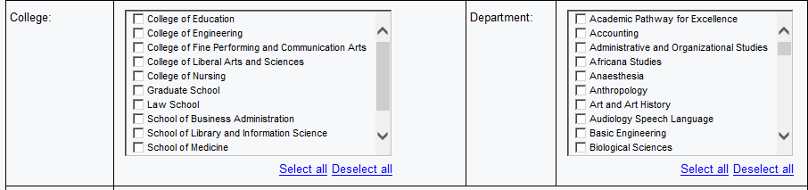

1. Enter your ***Access ID*** and click on ***Insert****.*

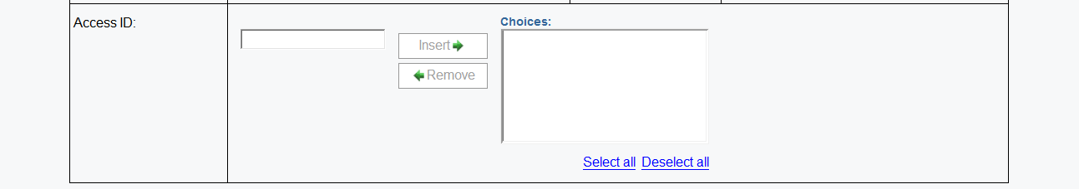

Click on “Finish”

Click on “Insert”

Enter “Access ID”

”



10*. Click on* ***Finish*** *to run your report.*

To Save or Print your Longitudinal Report:

1. Click on the **HTML** View in HTML Format icon item **10** second from the top right and a drop down box will appear giving four options for printing or saving your document. You may select ***View in PDF Format*** item **11** or choose another option***.***

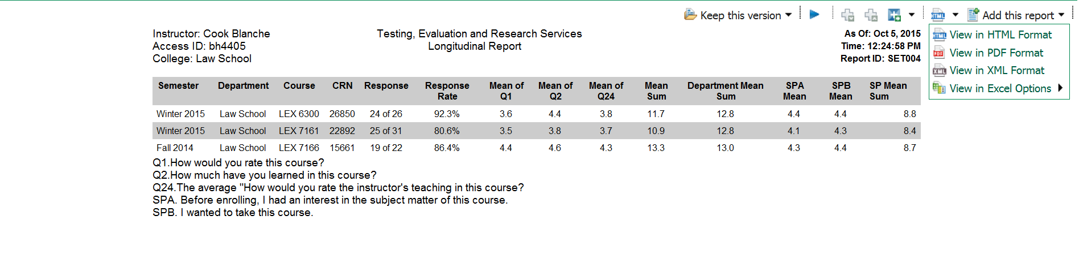

1. **Depending on your browser**, *move cursor* *across* the **top** or **bottom** of the report until the following ***Action Bar*** appears to **Save or Print** your document.

***Move cursor******across*** **top** or **bottom** of report for “Action Bar” to appear.

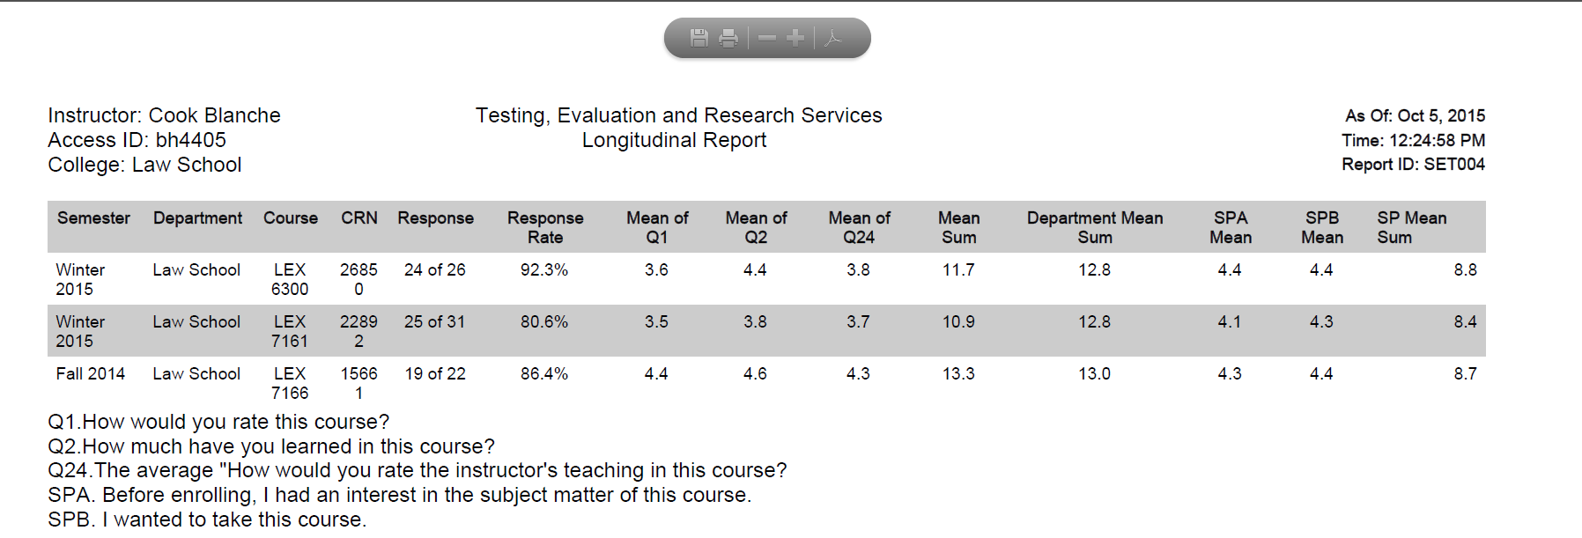

***Action Bar***



PRINT

SAVE

**110**

**100**

**2**