Testing, Evaluation and Research Services

*COGNOS REPORT DIRECTIONS*

***Faculty Individual Report***



Student Evaluation of Teaching (SET)

*seedu*

COGNOS

COGNOS, the software we use to distribute reports, does not work with Mozilla Firefox or Apple Safari for MAC computers. To retrieve reports, the following browsers are suggested:

* Google Chrome
* Microsoft Edge **

Connecting to the university's Global Protect VPN is necessary to access COGNOS off-campus and retrieve your SET reports. Go to <https://tech.wayne.edu/kb/security/wsu-virtual-private-network/500212>. To view the setup instructions for GlobalProtect. If you need assistance, please contact the C&IT Help Desk at (313) 577-4357.

Login to Academica

Departmental SET proxies or faculty teaching in the current semester will have access to the reporting system. *

Depending on your accessibility after logging into Academica, you can access COGNOS by either of two ways below:

* Under **Resources**
  + Click **Employee Resources** > **Administrative Systems** > **Banner** > **Business Intelligence Reporting Portal**
  + The Enterprise Analytics and Information Portal screen will display; click **Faculty.**

**OR**

* Under **Resources**
  + Click **Faculty Instructional Resources**.
  + Next, click **Student Evaluation of Teaching Reports** link.

*Faculty not currently teaching can go to their departmental [SET proxy](https://testing.wayne.edu/admin/evaluation/proxy-list) for assistance in retrieving their reports. If you do not have a departmental SET proxy, please complete a  [SET Technical Support Form](https://testing.wayne.edu/admin/evaluation/technical-support) and one of our team members will assist you.

Retrieving Faculty Reports

The **Testing, Evaluation and Research Services** report screen will display. Only your data will be available for download.

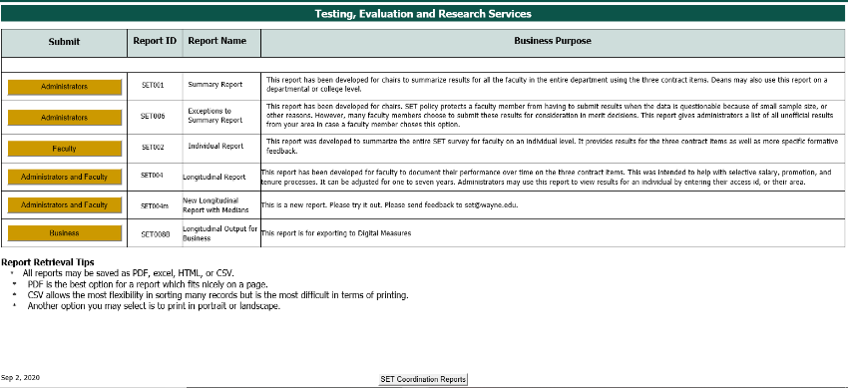

Faculty Individual Report - click on the Faculty (SET002) button.

***(If a blank screen appears when selecting any of the above links, please complete a***  [*SET Technical Support Form*](https://testing.wayne.edu/admin/evaluation/technical-support)***and one of our team members will assist you.)***

Top of Form

The Faculty Report screen is displayed. The steps to pull reports are below, see screen display on the following page.

1. Click on **one** or **more** Academic Periods.
2. Leave **College** and **Department** blank.
3. Enter **Access ID** (lowercase).
4. Tab over and click on **Insert**.
5. Next, click the **Finish** button to run your report(s).

Faculty Report screen

***(Academic Period is the Semester you are retrieving: First four digits are the year (2014), following two digits are the semester (01 = winter, 06 = spring/summer, 09 = fall) -- Ex. ‘201409’ = fall 2014.)***

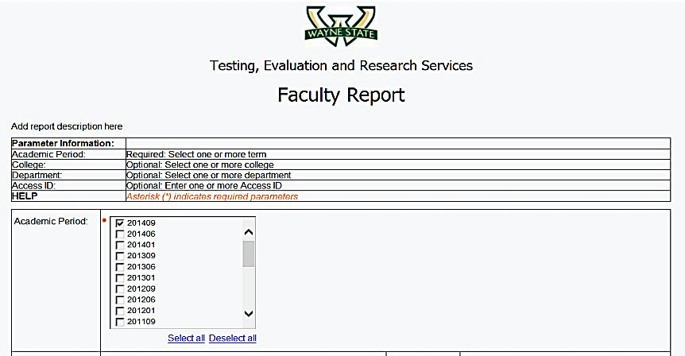

1

Select **one** or **more** Academic periods.

Academic Period(s)

Leave **College and Department** blank.

2

Tab over and enter **Access ID:** (lowercase letters)

a. Tab over and click the

Insertbutton.

b.Next, click the **Finish**

button to run reports.

3

***(All courses taught within a semester will be combined into one PDF. Each course will have two pages.)***

Save or Print Reports

* To **Save** or **Print**, click on the **Run AS** icon

located in the left upper menu. A drop-down box appears with various report output selections.

* If you prefer a PDF or Excel version of your report, click here. The Excel version gives your report in editable format which you can download and save to your computer.
* Follow your browser’s directions, as shown below, to Save or Print your report.



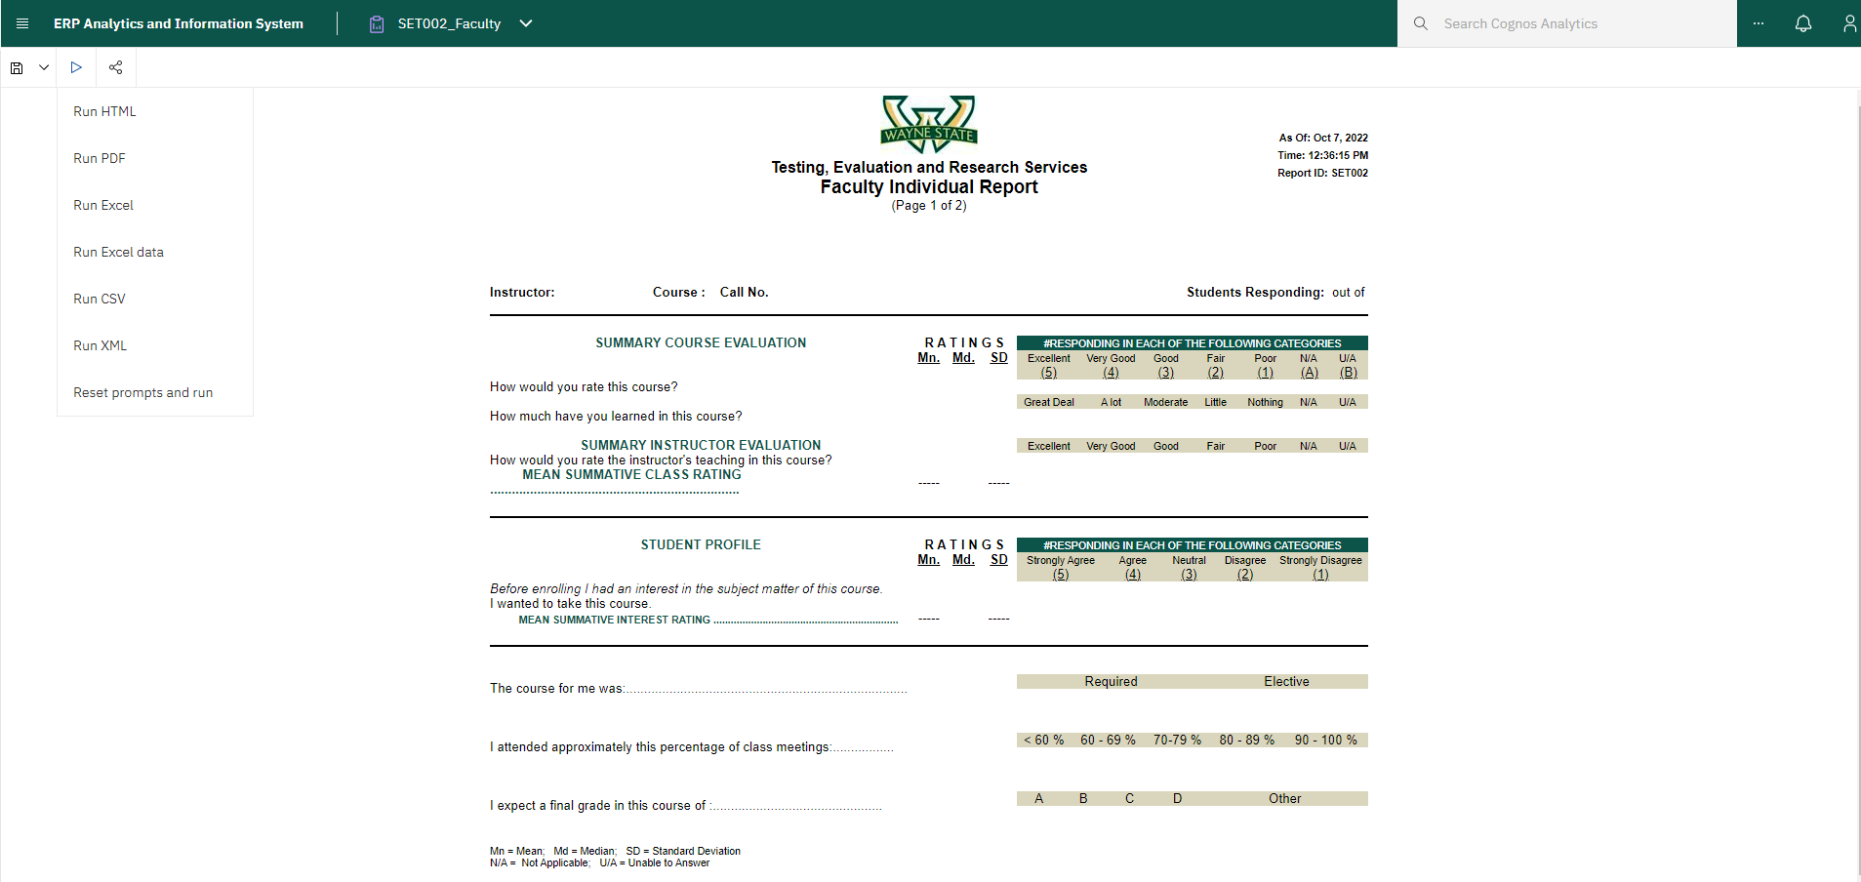

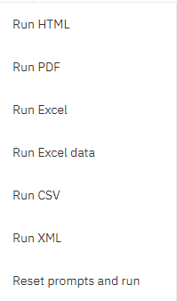





At the bottom left of the page, are scroll buttons  that allow you to view each report page.

The **Save and Print** icons are located at the top right of the report screens. Please follow the steps below for your browser output options.

**Chrome** and **Microsoft Edge** browser report output.

To **Save** your report to your computer, **click** on the **Download** icon.

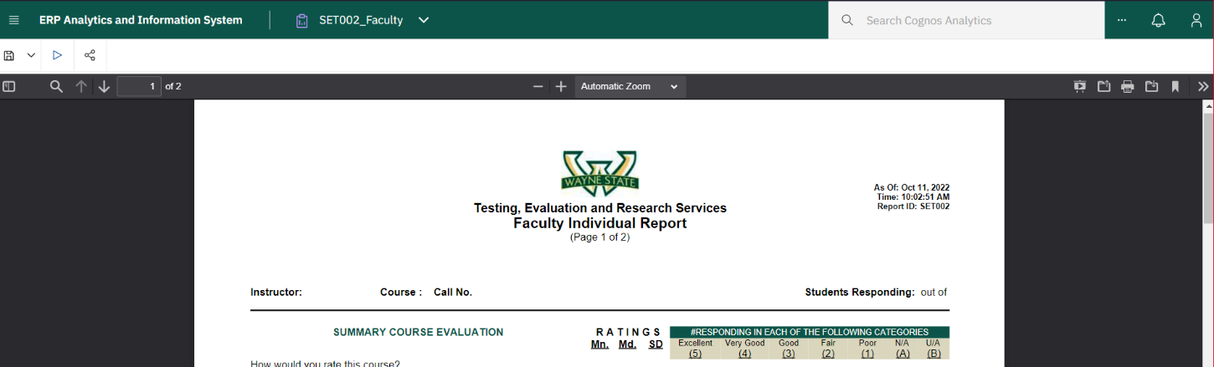



To **Print** your report, **click** on the **Printer** icon.