|  |
| --- |
| Student Evaluation of Teaching |
| Your guide to retrieving Dean administrative reports online |
| For more information, please contact set@wayne.edu or (313)577-3400. |
|  |



*We recommend using the following browsers:*

* *Internet Explorer* http://png-2.findicons.com/files/icons/1008/quiet/128/internet_explorer.png
* *Mozilla Firefox (35.0.1)*
* *Safari (v8.0.6) for MAC users*

1. Log into **Academica:**

***Accessing from home (on-campus users please disregard)***

*To access COGNOS from home, please visit* [https://computing.wayne.edu/vpn/](https://computing.wayne.edu/vpn/f)*.* ***Please contact the C&IT Help Desk 313.577.4778 for assistance as needed.***

1. Look to the left of the screen for menu selections under***WSU Resources***-- click on the second option***Faculty Instructional Resources****.*
2. Under***Faculty Instructional Resources*** *--* scroll down and click on***Student Evaluation of Teaching Reports*** (which is the third option from the bottom).

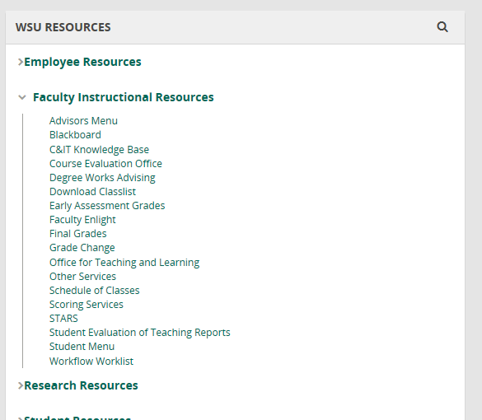

Look to the left of the screen under **“*WSU RESOURCES”*** click on

***“Faculty Instructional Resources”*** next click on “***Student Evaluation of Teaching Reports***”

The following ***Testing, Evaluation and Research Services*** screen will appear.

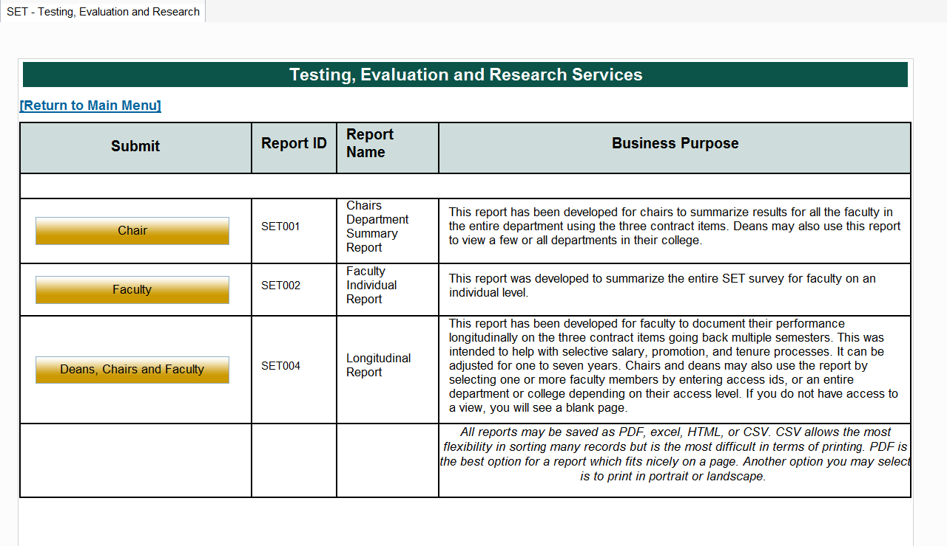

* 1. **Deans**: To retrieve Summary reports for Departments within your College **only**, click on the ***Chair*** link above*. (Please note: Your access will not allow you to retrieve Summary reports for* ***Departments*** *not within your college.)*

Note: If a blank screen appears when selecting the Chair link, please email [set@wayne.edu](mailto:set@wayne.edu) for assistance.

* 1. To retrieve a **Faculty Individual Report**, click on the ***Faculty*** link above.

Note: If a blank screen appears when selecting the Faculty link, please email [set@wayne.edu](mailto:set@wayne.edu) for assistance.

Top of Form

|  |  |  |
| --- | --- | --- |
| ***“College”*** | The following ***Chairs Department Summary Report*** screen will appear.   1. To retrieve reports for your entire **College:**  * Select ***one*** term using the Academic Period drop down box provided below. * Move to the box marked ***College*** and using the scroll bar to the right of the box, scroll down and select your *College.* * Leave ***Department*** blank.  1. To retrieve reports for a certain **Department** within your college:  * Select ***one*** term using the Academic Period drop down box provided below. * Click on your ***College.*** * Next, click on the ***Department(s*)** within your college.   *Note: Academic Period is the Semester you are retrieving: First four digits are the year (2014), next*  *two digits are the semester (01 = Winter, 06 = Spring/Summer, 09 = Fall) -- Ex. ‘201409’ = Fall 2014*.    ***“Academic Period”*** |  |

***“Department”***

1. Leave ***Access ID*** blank.

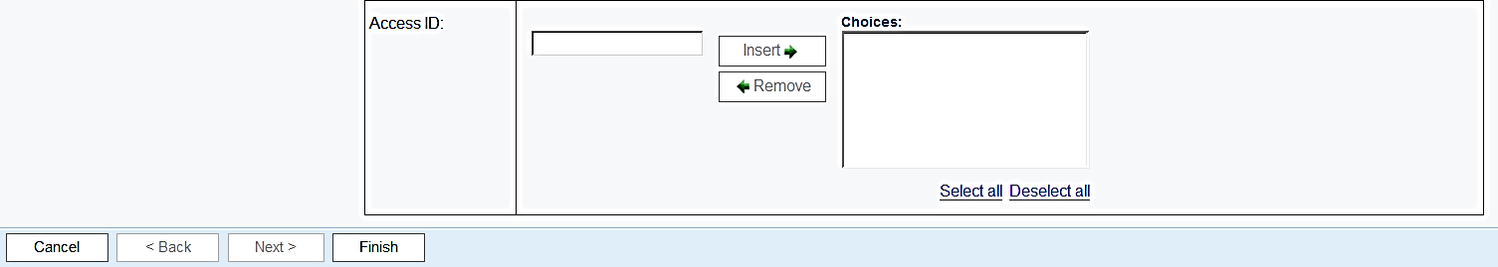

Click on **“*Finish”***

1. Click on ***Finish*** to run your report(s).

**Retrieving a Faculty Individual Report(s).**

To retrieve a ***Faculty*** report(s), click on the ***Faculty*** link and select **one** or ***more*** *Academic Periods* from the box below.

*(Note: Academic Period is the Semester you are retrieving: First four digits are the year (2014), next two digits are the semester (01 = Winter, 06 = Spring/Summer, 09 = Fall) -- Ex. ‘201409’ = Fall 2014.)*

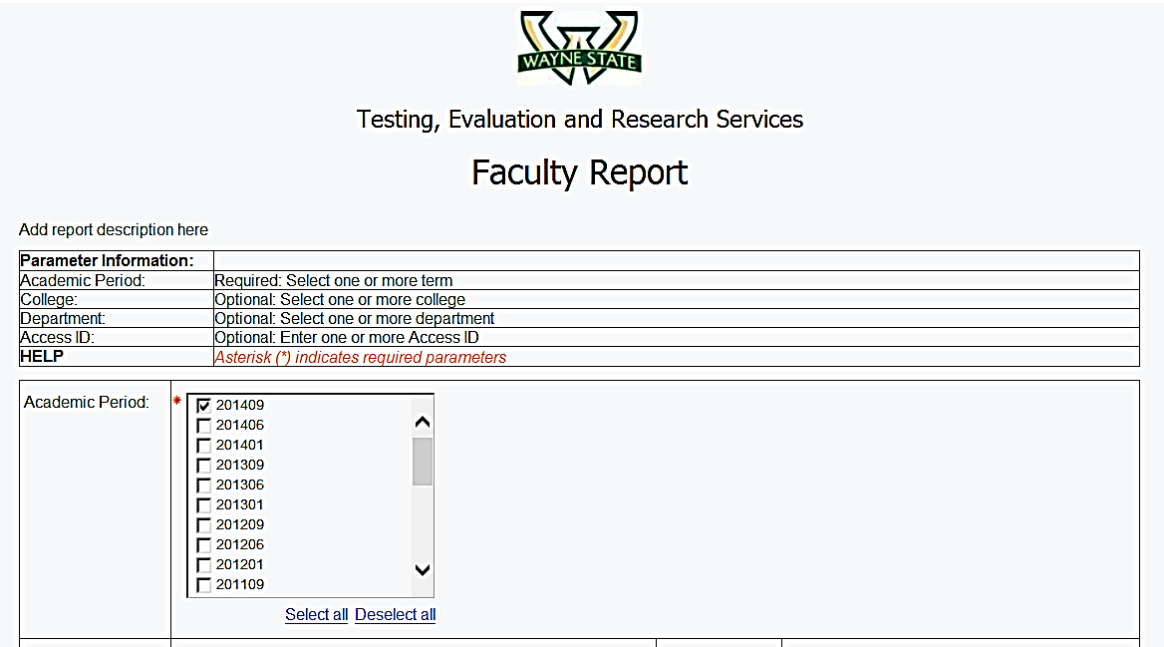

Select one or more **“*Academic Periods”***

**Leave College/Department blank.**

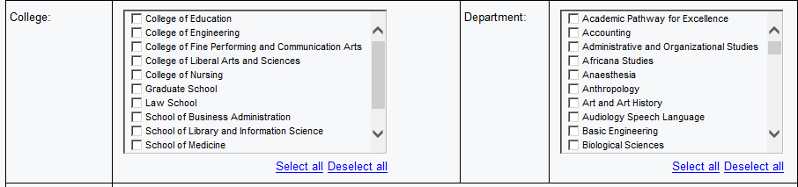

Enter ***Access ID(s)*** and click on **Insert**.

**

Click on ***“Finish”***

Enter ***“Access ID”***

Click on ***“Insert”***

Click on ***Finish*** to generate your Faculty Individual Report(s).

**To Save or Print your reports:**

1. Click on the **HTML** View in HTML Format icon item **8** from the top right and a drop down box will appear giving four options for printing or saving your document. You may select ***View in PDF Format***item **9** or choose another option*.*

**9**

**8**

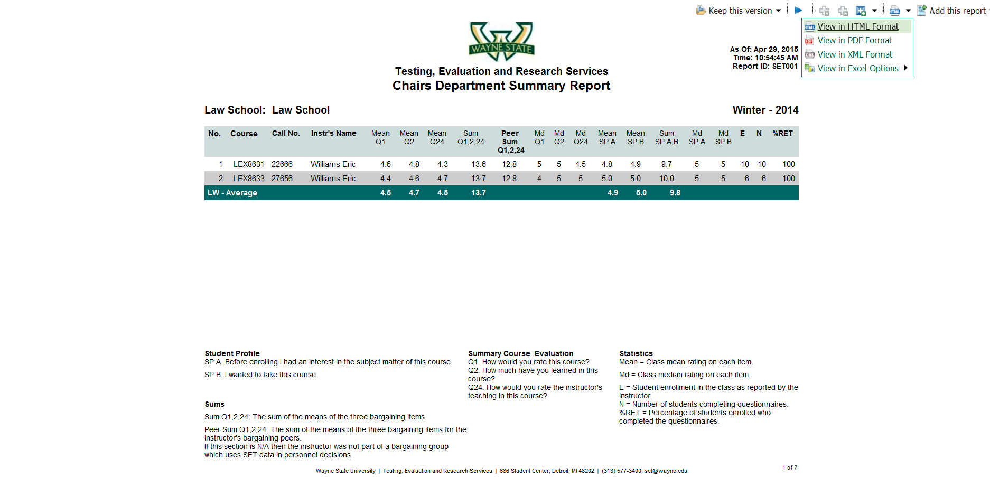

1. Depending on your browser, *move cursor across* the **top** or **bottom** of the report until the following **Action Bar** appears to **Save or Print** your document.

*Move cursor across* **top** or **bottom** of report for “Action Bar” to appear



*Action Bar*



SAVE

PRINT