|  |
| --- |
| Student Evaluation of Teaching |
| Your guide to accessing Dean administrative longitude results online |
| For more information, please contact set@wayne.edu or (313)577-3400 |
|  |



*We recommend using the following browsers to access COGNOS.*

* *Internet Explorer*http://png-2.findicons.com/files/icons/1008/quiet/128/internet_explorer.png
* *Mozilla Firefox (35.0.1)*
* *Safari (v8.0.6) for MAC users*

1. Log into **Academica**

***Accessing from home (on-campus users please disregard)***

*To access COGNOS from home, please visit* [https://computing.wayne.edu/vpn/](https://computing.wayne.edu/vpn/f)*.* ***Please contact the C&IT Help Desk 313.577.4778 for assistance as needed.***

1. Look to the left of the screen for menu selections under ***WSU Resources***.
2. Click on the second option **Faculty Instructional Resources**.
3. Under **Faculty Instructional Resources** -- scroll down and click on ***Student Evaluation of Teaching Reports*** (which is the third option from the bottom.

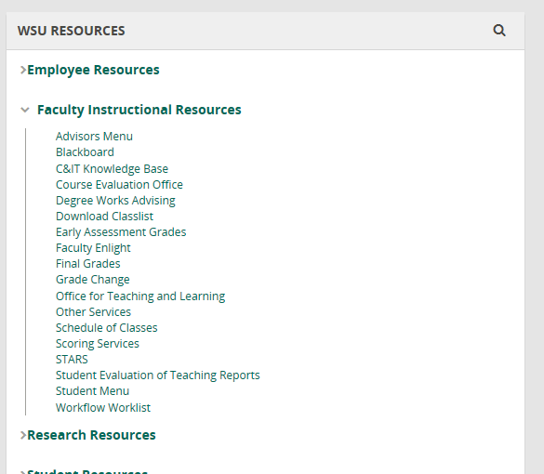

Look to the left of the screen under **“*WSU RESOURCES”*** click on

***“Faculty Instructional Resources”*** next click on “***Student Evaluation of Teaching Reports***”

The following ***Testing, Evaluation and Research Services*** screen will appear.

1. Click on the ***Deans, Chairs and Faculty*** link below (located on the left side of the screen).

Top of Form

|  |  |  |
| --- | --- | --- |
|  |  |  |

Click on **“Deans, Chairs and Faculty”** link for a

Longitudinal Report.

The following ***Longitudinal Report*** screen will appear.

1. To retrieve reports for your entire **College:**

* Click on the ***Academic Period Start:*** drop down box and select the (**oldest term**) for your starting Academic period.
* Next, click on the ***Academic Period End:*** drop down box and select the (**current term**) for your ending Academic Period.
* Click on your **College**.
* Leave ***Department*** blank.

1. To retrieve reports for a certain **Department** within your college:

* Click on the ***Academic Period Start:*** drop down box and select the (**oldest term**) for your starting Academic period.
* Next, click on the ***Academic Period End:*** drop down box and select the (**current term**) for your ending Academic Period.
* Click on your **College**.
* Next, click on a **Department(s)** within your college.

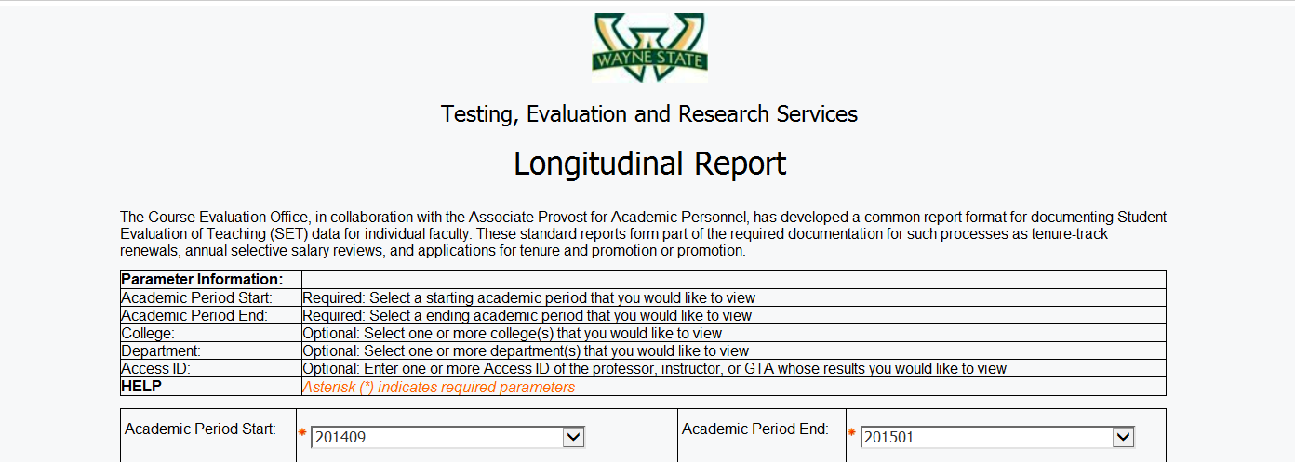

Select the **Academic Period End:** (**current term**) from the drop down box.

Select the **Academic Period Start:** (**oldest term**) from the drop down box.

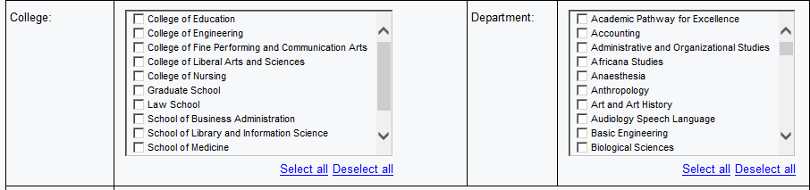

***“Department”””***

***“College”***

1. Leave ***Access ID*** blank.

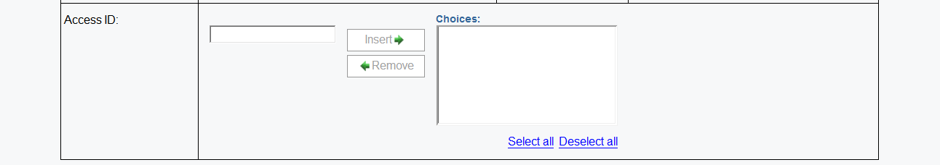

Click on ***“Finish”***



1. Click on ***Finish*** to generate your report.

**To Save or Print your reports:**

1. Click on the **HTML** View in HTML Format icon item **10** from the top right and a drop down box will appear giving four options for printing or saving your document. You may select ***View in PDF Format***item **11** or choose another option*.*

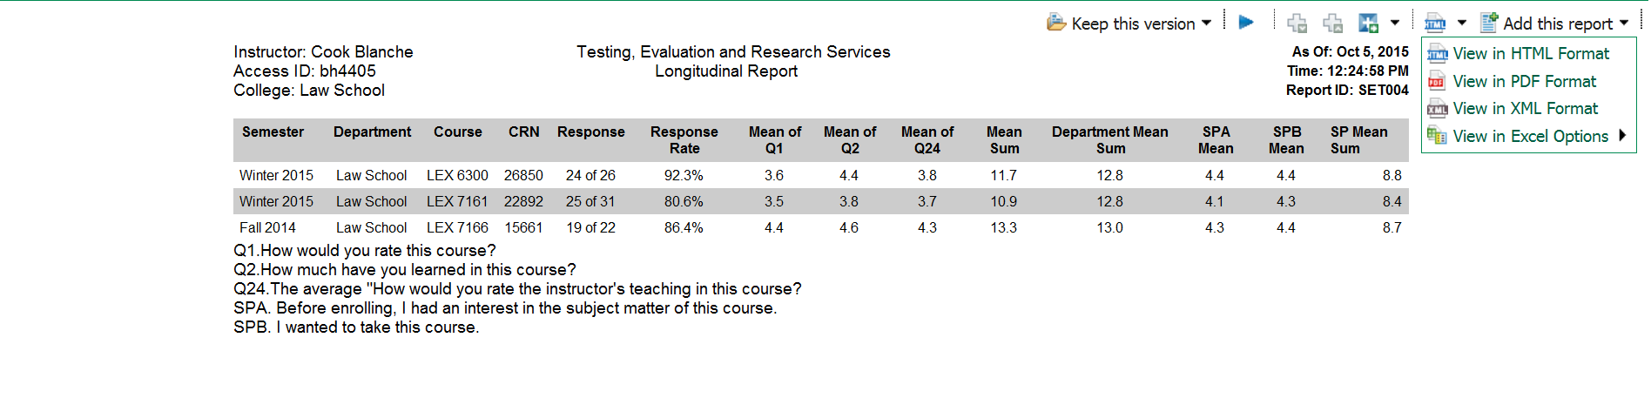

1. **Depending on your browser**, move cursor across the **top** or **bottom** of the report until the following ***Action Bar*** appears to **Save or Print** your document.

**11**

**100**

Move cursor across **top** or **bottom** of report for “Action Bar” to appear.

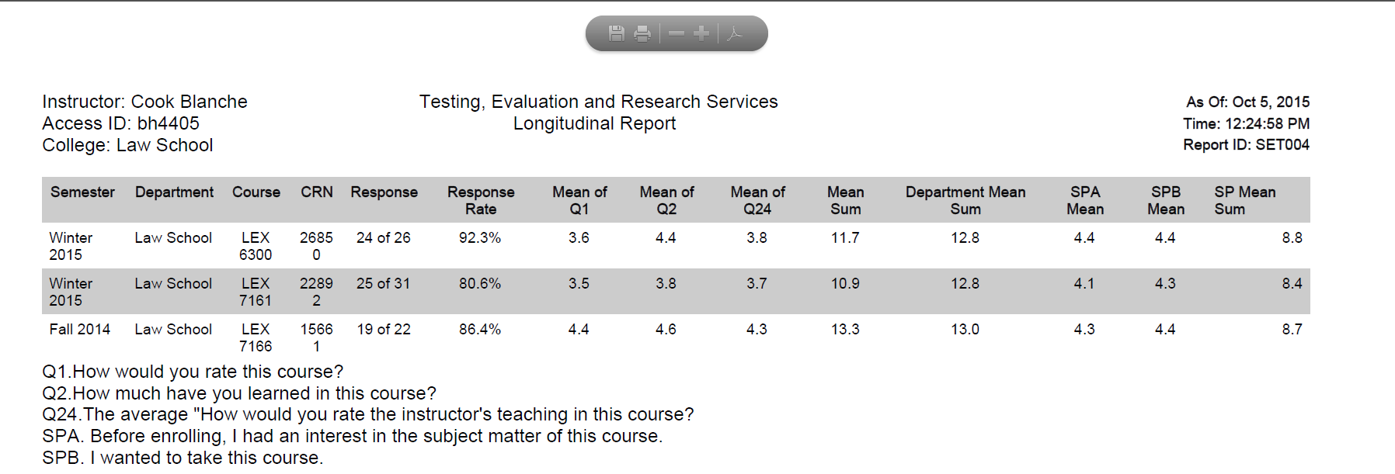

***Action Bar***



PRINT

SAVE