|  |
| --- |
| Student Evaluation of Teaching |
| Your guide to retrieving CHAIR administrative reports online |
| For more information, please contact set@wayne.edu or (313)577-3400. |
|  |



*We recommend using the following browsers:*

* *Internet Explorer* http://png-2.findicons.com/files/icons/1008/quiet/128/internet_explorer.png
* *Mozilla Firefox (35.0.1)*
* *Safari (v8.0.6) for MAC users*

1. Log into **Academica:**

***Accessing from home (on-campus users please disregard)***

*To access COGNOS from home, please visit* [https://computing.wayne.edu/vpn/](https://computing.wayne.edu/vpn/f)*.* ***Please contact the***

***C&IT Help Desk 313.577.4778 for assistance as needed.***

1. Look to the left of the screen for menu selections under***WSU Resources***-- click on the second option***Faculty Instructional Resources****.*
2. Under***Faculty Instructional Resources*** *--* scroll down and click on***Student Evaluation of Teaching Reports*** (which is the third option from the bottom).

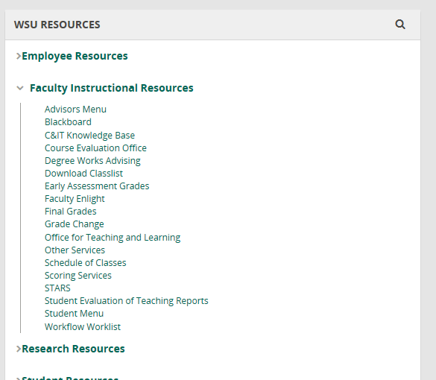

Look to the left of the screen under **“*WSU RESOURCES”*** click on

***“Faculty Instructional Resources”*** next click on “***Student Evaluation of Teaching Reports***”

The following ***Testing, Evaluation and Research Services*** screen will appear.

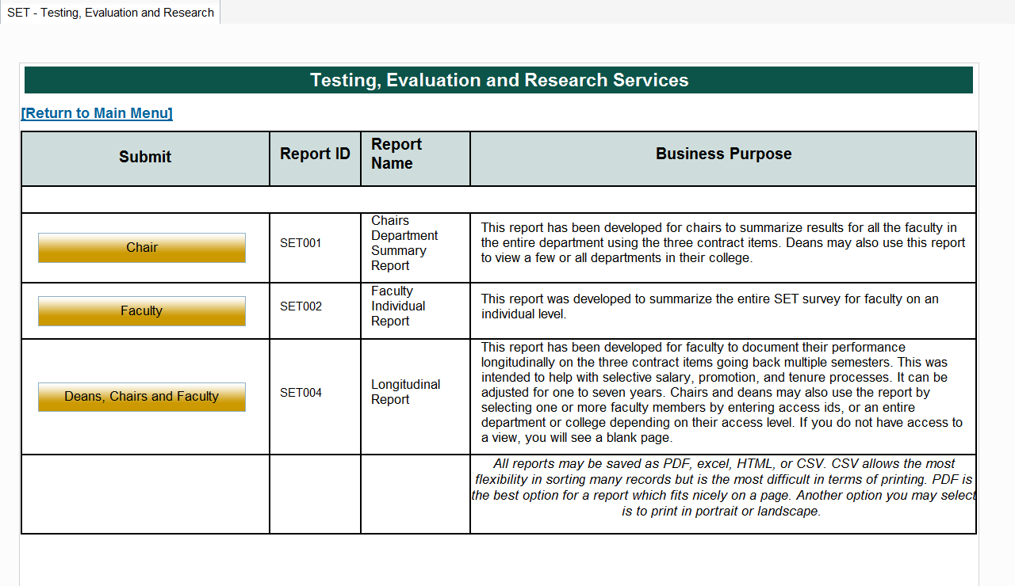

* 1. To retrieve your **Department Summary Report**, click on the ***Chair*** link above.

Note: If a blank screen appears when selecting the Chair link, please email [set@wayne.edu](mailto:set@wayne.edu) for assistance.

* 1. To retrieve the **Faculty Individual Report**, click on the ***Faculty*** link above.

Note: If a blank screen appears when selecting the Faculty link, please email [set@wayne.edu](mailto:set@wayne.edu) for assistance.

Top of Form

|  |  |  |
| --- | --- | --- |
|  | The following ***Chairs Department Summary Report*** screen will appear.   1. Select ***one*** term using the Academic Period drop down box provided below. 2. Click on ***College***. 3. Next, click on ***your*** Departmen*t*.   *Note: Academic Period is the Semester you are retrieving: First four digits are the year (2014), next*  *two digits are the semester (01 = Winter, 06 = Spring/Summer, 09 = Fall) -- Ex. ‘201409’ = Fall 2014*.    **“College”**  **“Academic Period”**  **“Department”** |  |

1. Leave ***Access ID*** blank.

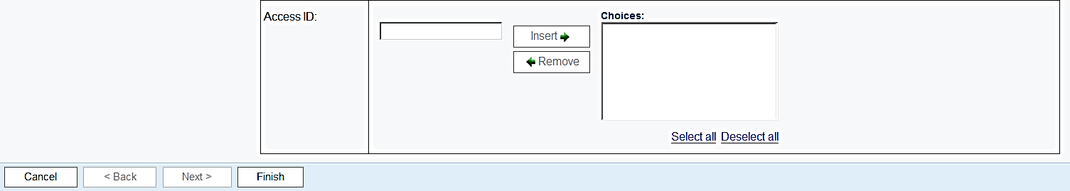

Click on “**Finish”**

1. Click on ***Finish*** to run your *Chairs Department Summary Report.*

**Retrieving a Faculty Individual Report.**

To retrieve ***Faculty Reports(s)***, click on the ***Faculty*** link and select **one** or ***more*** Academic Periods from the box below.

*(Note: Academic Period is the Semester you are retrieving: First four digits are the year (2014), next two digits are the semester (01 = Winter, 06 = Spring/Summer, 09 = Fall) -- Ex. ‘201409’ = Fall 2014.)*

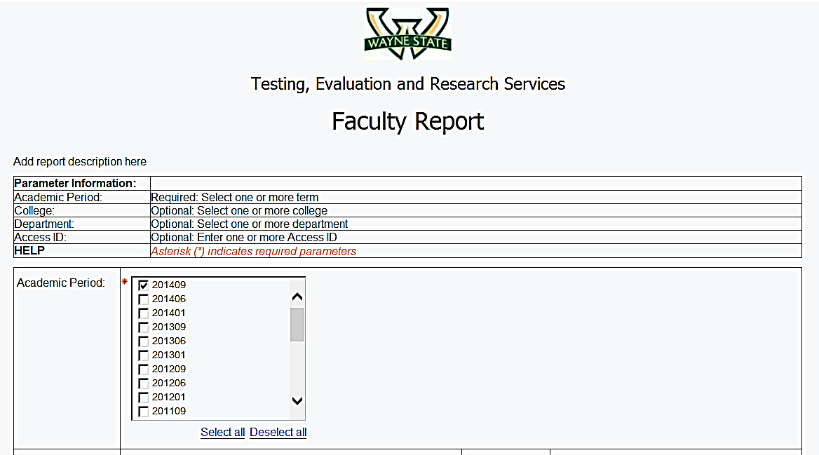

Select **one** or **more “*Academic Periods”***

**Leave College/Department blank.**

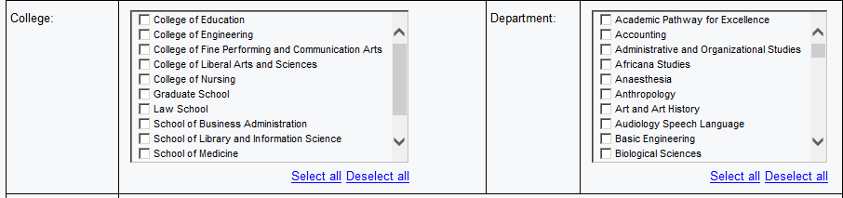

Enter ***Access ID(s*)** and click on ***Insert***.  *(If Access ID is unknown, please click on* ***your*** *Department. The system will generate reports for all instructor taught courses within your department.)*

**

Click on **“Finish”**

Enter **“Access ID”**

Click on **“Insert”**

Click on ***Finish*** to run your Faculty Individual Report(s).

**To Save or Print your reports:**

1. Click on the **HTML** View in HTML Format icon item **9** from the top right and a drop down box will appear giving four options for printing or saving your document. You may select ***View in PDF Format***item **10** or choose another option*.*

**10**

**9**

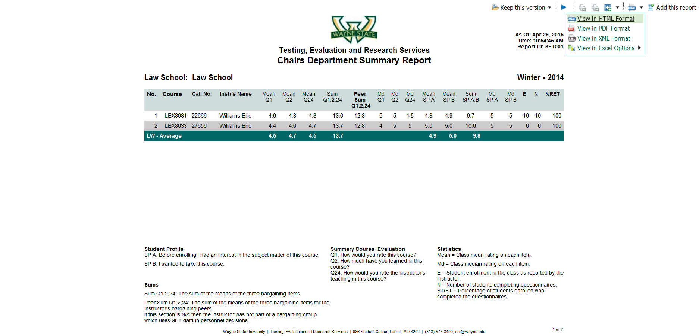

1. Depending on your browser, *move cursor across* the **top** or **bottom** of the report until the following **Action Bar** appears to **Save or Print** your document.

*Move cursor across* **top** or **bottom** of report for “Action Bar” to appear

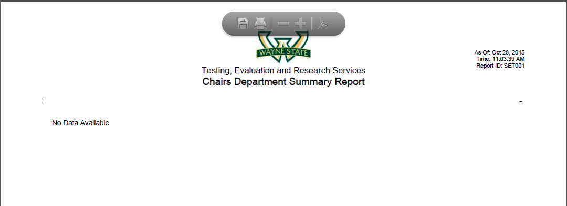

*Action Bar*

PRINT



SAVE